Motorola MICOR High Band to 220 MHz Conversion

RECEIVER

Order Crystals from International Crystal Manufacturing (405) 236-3741.

Crystal formula: Fxtal = (Frx-11.7)/12
International Catalog Number: 161186
Motorola Channel Element: K1005A

Step 1: Remove Aux. RX board from rear and Aux. control Board and set aside… They will not be reused.

Step 2: Remove Main Rx board and replace the following components with the values shown:

C108 - 27pf NPO disk
C109 - 39pf N150 disk
C113 - 2.2pf NPO disk
C116 - 2.2pf NPO disk

You need to remove the Metal shields from the 4 coils at the rear end of the RX board to access these Caps.
Remove the 2 screws holding item 29, then remove item 29. Unsolder 2 tabs on each of the item 12 shields
And remove.

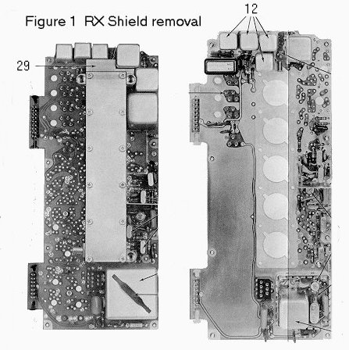

Step 3: Connect Orange wire from Rx Board TP to location shown in Fig. 2.

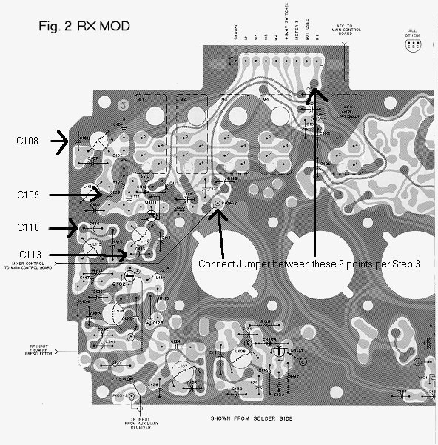

Step 4: Modify Helical resonator coils per Figure 3. The resonators are held in with 2 screws each.
Remove resonator assembly from main RX board before attempting to modify it.

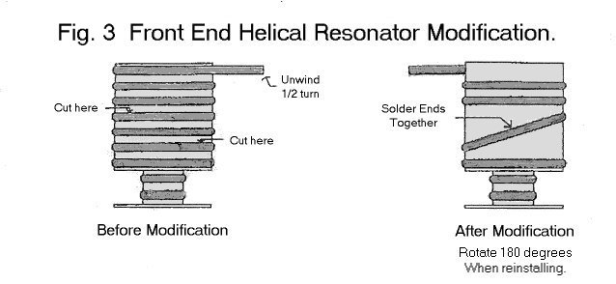

Step 5: Reinstall Main RX board.

Step 6: Connect Coax that used to go to AUX RX board antenna input to Main antenna input.

Step 7: Set channel jumpers on Control Board per figure 4.

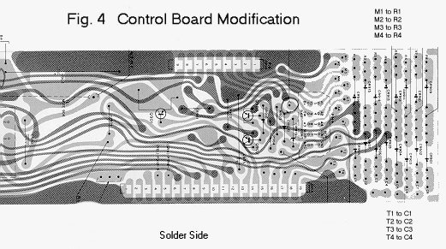

Step 8: Tune per Motorola Manual.

NOTE: A GAASFET Preamp may be needed for optimum sensitivity.

EXCITER MODIFICATION

Order Crystals from International Crystal Manufacturing (405) 236-3741.

Crystal formula: Fxtal = Ftx/12
International Catalog Number: 161184Y
Motorola Channel Element: K1007A

Step 1: Remove Exciter PCB and change the following components to the new values shown:

C430 – 68pf 5% Silver Mica C447 – 10pf NPO Disk R429 - 180 ohm 1/2 watt
C433 – 150pf 5% Silver Mica C448 – 15pf NPO Disk
C434 – 120pf 5% Silver Mica C451 – 4.7pf NPO Disk
C437 – 22pf 5% Silver Mica C452 – 7.5pf NPO Disk
C439 – 22pf 5% Silver Mica C455 – 3.9pf NPO Disk
C440 – 47pf 5% Silver Mica C456 – 4.7pf NPO Disk
C443 – 15pf 5% Silver Mica C458 – 1.5pf NPO Disk
C444 – 12pf 5% Silver Mica C460 – 75pf 5% Silver Mica

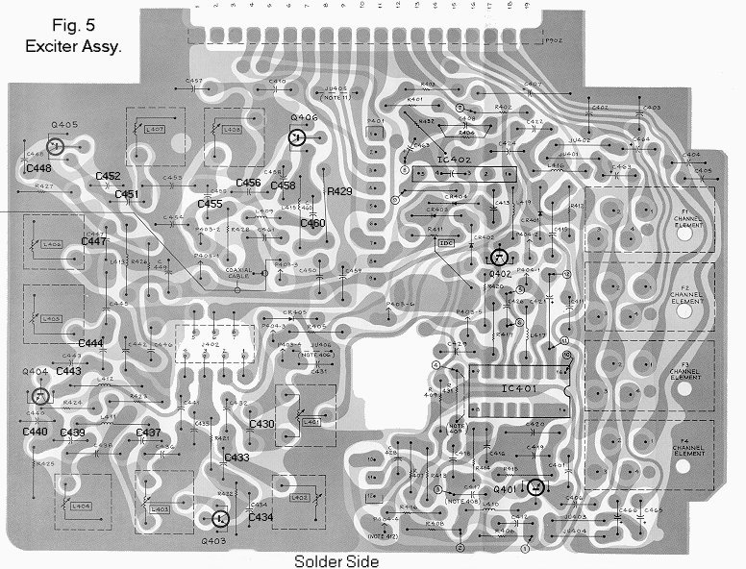

Step 2: Reinstall Exciter PCB and tune in accordance with Motorola manual. Exciter should
Produce approximately 100mW.

EXCITER FILTER (Z501)

This is Optional. The radio will operate without the filter in line, but using this filter may reduce the white noise output of the exciter.

There are 5 slug-tuned coils in this filter. It is symmetrical.

Step 1: Remove filter from the casting.

Step 2: Remove the cover from the filter.

Step 3: Remove 1 turn from the outermost coils in the filter (coils connected to the input and output).

Step 4: Remove 1 turn from the center coil in the filter.

Step 5: Remove 2 turns from the remaining 2 coils.

Step 6: Tune the coils for minimum VSWR at the operating frequency. Tuning will change when it is assembled, so make
an adjustment, then put the cover back on to check it.

Step 7: Re-assemble and re-install in the casting.

POWER AMPLIFIER

Step 1: Remove the MICOR power amplifier PC Board and discard. It is not tunable to 220MHz.
Save all hardware.

Step 2: Unsolder the wires from the Positive feedthrough capacitor and unscrew it from the casting.

Step 3: Install the Positive feed through capacitor in the hole next to the negative feedthrough.

Step 4: Re-connect the positive wire and filter cap to the feedthrough.

Step 5: Construct the Toshiba power module based amplifier per the schematic. (fig 6)
And mount the module to a 3/16” thick X 3 ½” X 5” aluminum plate where the
Original PA board was mounted (Fig. 8) Use heat sink compound between the module
And plate, and between the plate and casting.

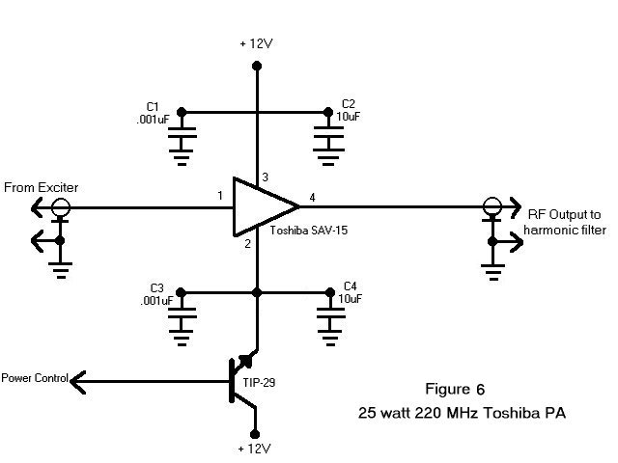

Step 6: Wire the PA to the Exciter output, +12V, Gnd., and to the Harmonic filter.

Step 7: Wire the Blue power control wire to the Base of the pass transistor
(Mounted where the old PA board Pass transistor was with new insulators etc)

LOW PASS FILTER

This modification changes the cutoff frequency of the harmonic lowpass filter from 190 MHz to approximately 230 MHz.

Step 1: Remove the filter from the main casting by removing 4 screws.

Step 2: Remove the cover to the harmonic filter by removing the 2 screws on the rear of the unit.

Step 3: Remove 1 turn from the center of each coil, and solder the 2 ends back together.
Stretch the coils to their original length and fine tune length for minimum VSWR. (See Fig. 7)

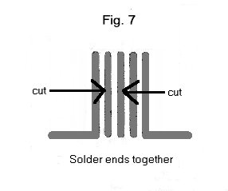
Step 4: Re-assemble and re-install filter assembly in Radio.

The Radio should make 25-30 watts output and the power control board should work exactly as it did with the original PA.

